App in a Day

Hands-on Lab Step-by-Step

May 2020

Contents

Importing Module 3 Completed 1

Task 1: Create a new environment 1

Task 2: Import the solution 2

Task 4: Test Device Procurement App 6

# Importing Module 3 Completed

Follow the steps below, if you did not complete Modules 1, 2 or 3 and would like to skip to Module 4

## Task 1: Create a new environment

1. Open a new browser tab, navigate to [Power Apps admin portal](https://admin.powerplatform.microsoft.com/) select **Environments** and click **New Environment**.

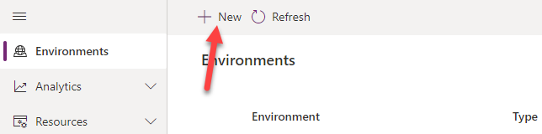

1. Provide an **Environment Name**, select **Trial** for **Type**, select **Region**, select **Yes**, for **Create** a database, and click **Next**.

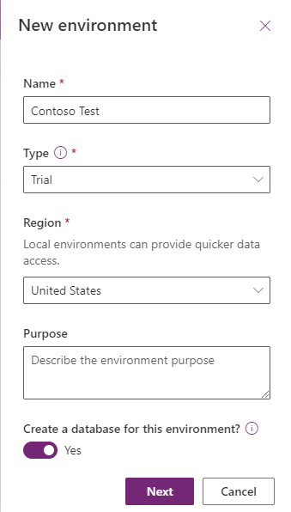

1. Select **Language,** select **Currency**, select **Yes** for **Deploy sample apps** **and data** and then click **Save**.

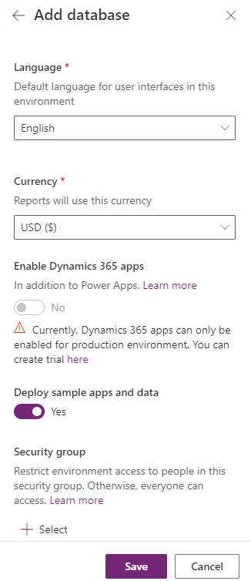

1. Wait for the environment to be created.

## Task 2: Import the solution

In this task, you will import the completed module 3 solution.

1. Navigate to [Power Apps maker portal](https://make.powerapps.com/)
2. Make sure you are in the **Contoso Test** Environment you created.
3. Select **Solutions.**

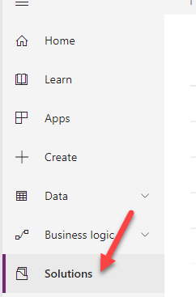

1. Click **Import**.

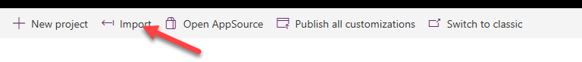

1. Click **Browse**.

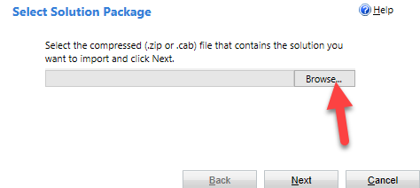

1. Select the **Module 3 Completed Solution** zip file located in Module 3 Completed folder and click **Open**.

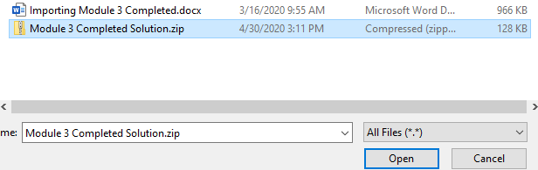

1. Click **Next**.

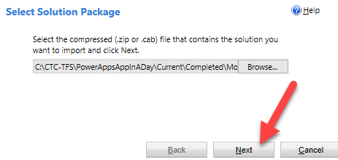

1. Click **Next** again.
2. Click **Import**.

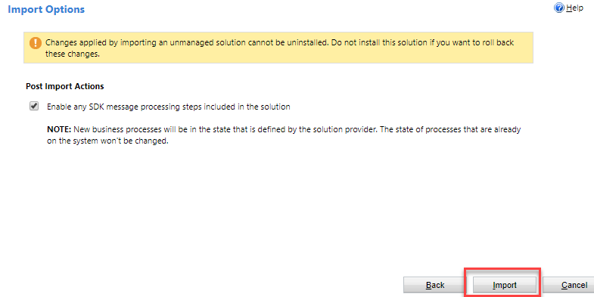

1. Wait for the solution import to complete and click **Close**.

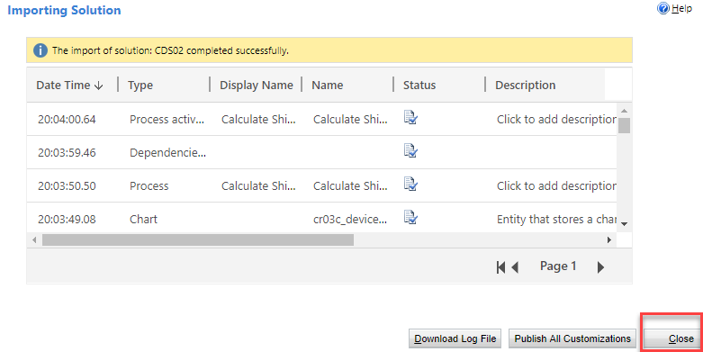

1. Click **Publish All Customizations** and wait for the publishing to complete.

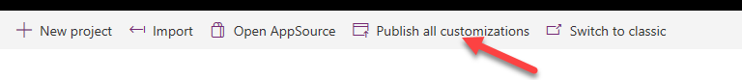

1. Select **Apps**, click on the **…** button of the application you imported and click **Play**.

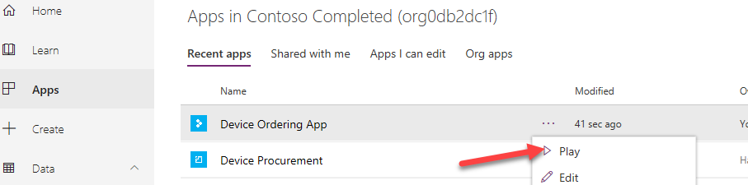

1. Click **Allow**.

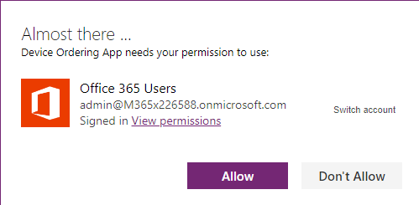

1. Select few devices and click **Compare**.

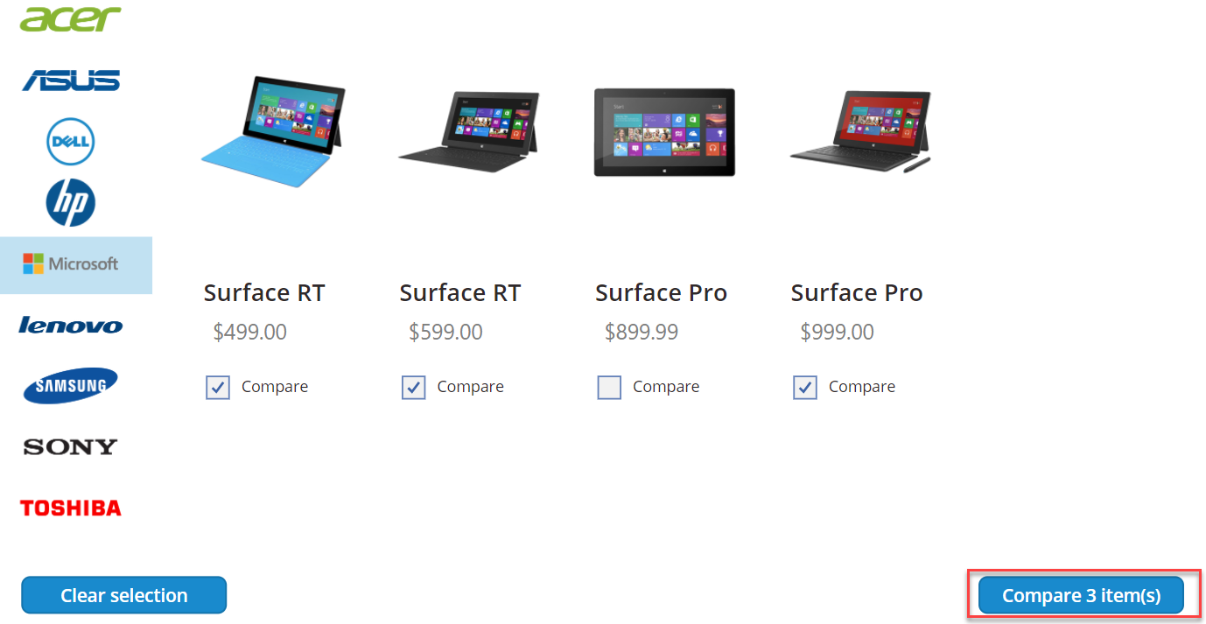

1. Select one of the devices and click **Submit**.

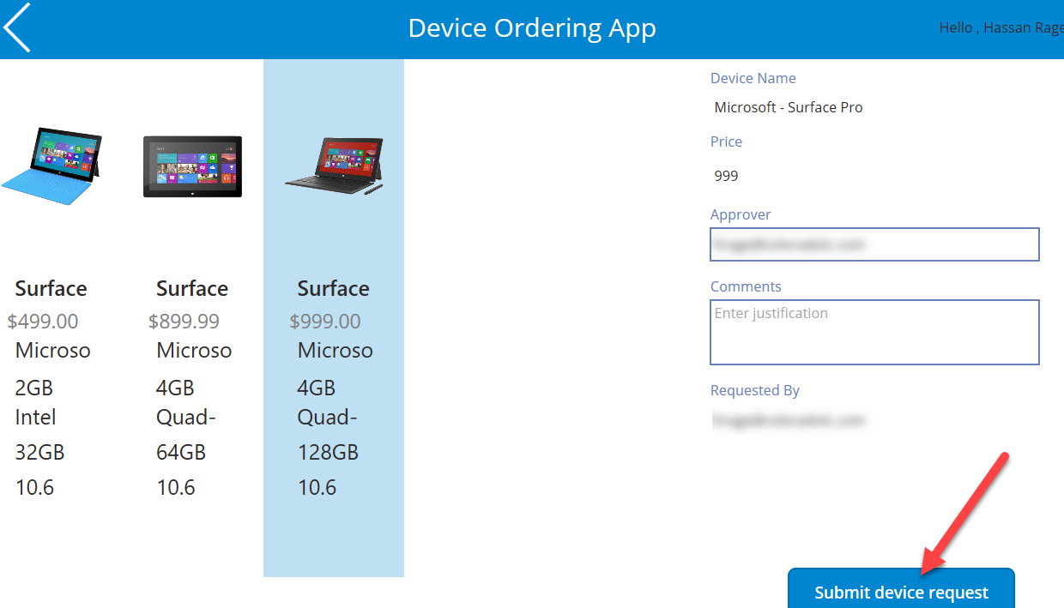

1. Click **OK**.

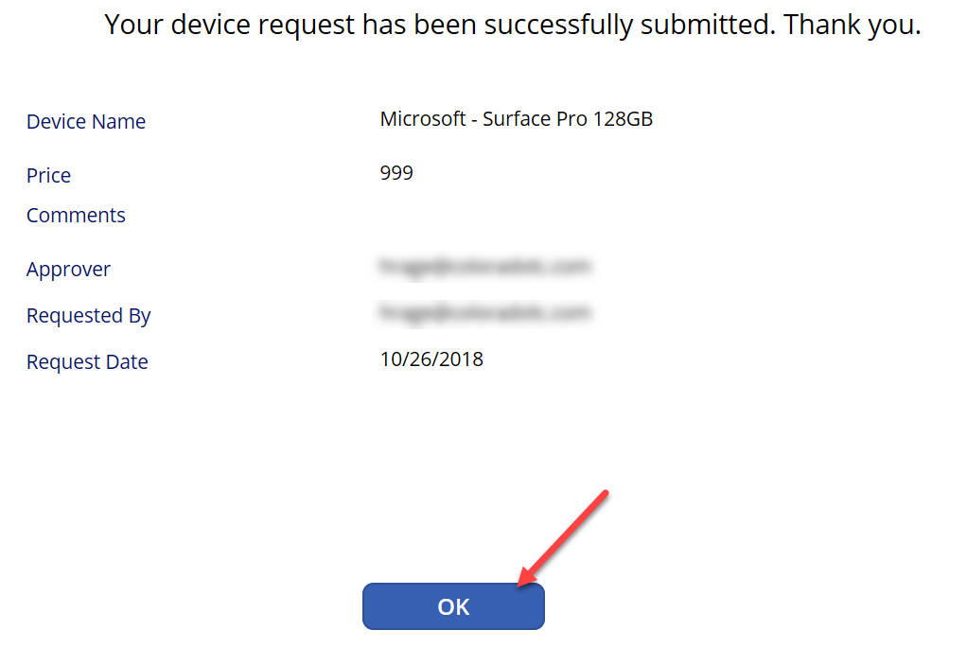

1. Close the application.

## Task 4: Test Device Procurement App

1. Select App and start the Device Procurement application.

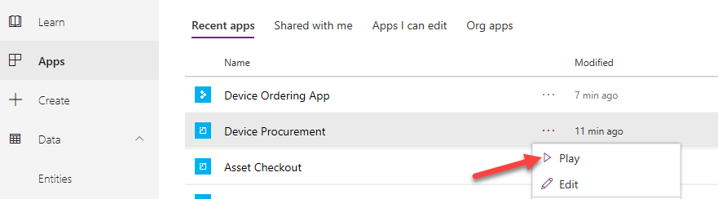

1. You should see the device you ordered on the list.

